Activity Sheet Name Chapter 5, Lesson 5
Using Dissolving to Identify an Unknown Date

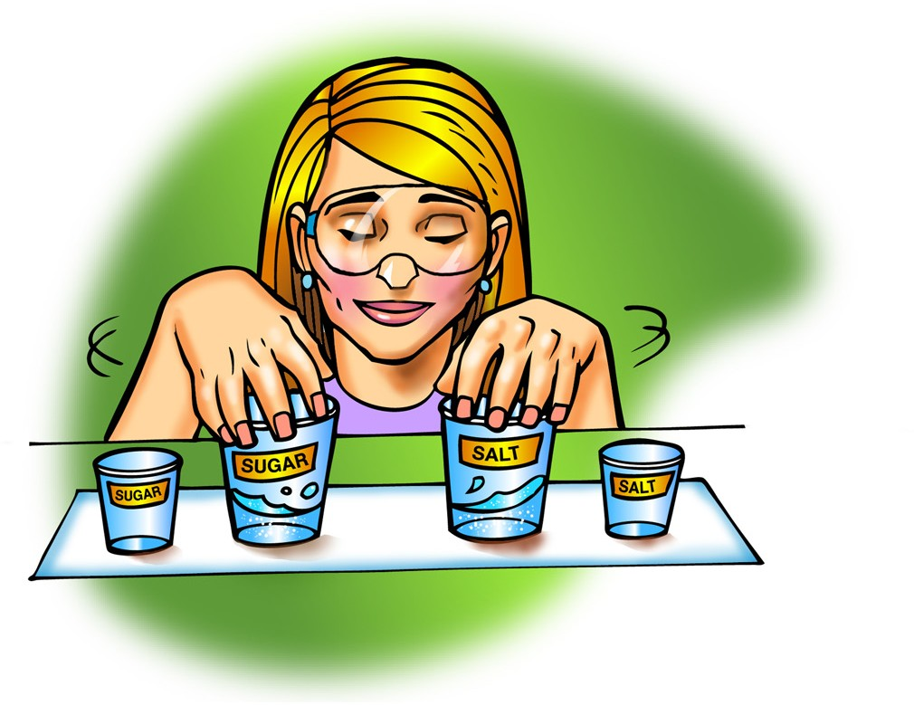
DEMONSTRATION
- Your teacher did a demonstration comparing the amount of salt and sugar that dissolved in a small amount of water.

Was there more salt or sugar left in the bottom of the cup?

Which dissolved better, salt or sugar?

- How well a substance dissolves in water is called its solubility. Would you expect different substances to have the same or different solubility?

Why?

ACTIVITY

Question to Investigate
Can you identify the unknown crystal by the way it looks?

Materials for Each Group
  - Black construction paper
  - Masking tape
  - Pen or permanent marker
  - 5 small plastic cups
  - Salt
  - Epsom salt
  - MSG
  - Sugar
  - Unknown
  - Magnifier

Procedure
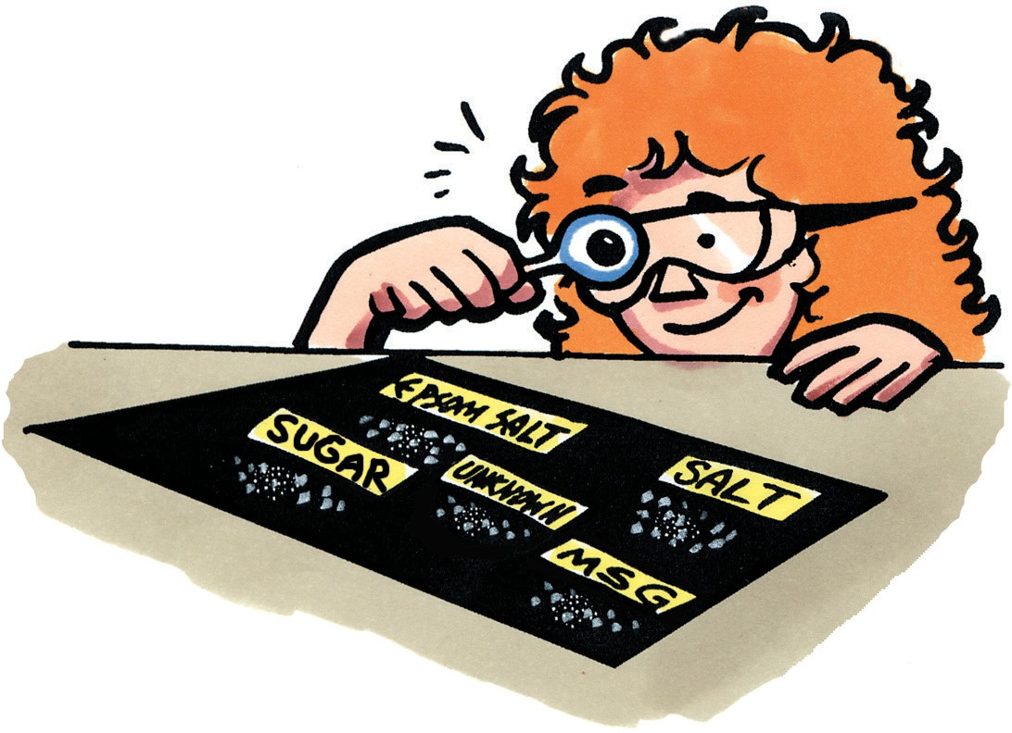
- Use masking tape and a pen to label four corners of a piece of black construction paper Sugar, Salt, Epsom salt, and MSG. Label the center unknown.
- Place small samples of Epsom salt, table salt, sugar, MSG, and the unknown on the labeled areas of the construction paper.
- Use a magnifier to look carefully at each type of crystal.

- What do you notice about each crystal? Include any similarities or differences you notice among them.

- What do you think might be the identity of the unknown from what you have seen so far?
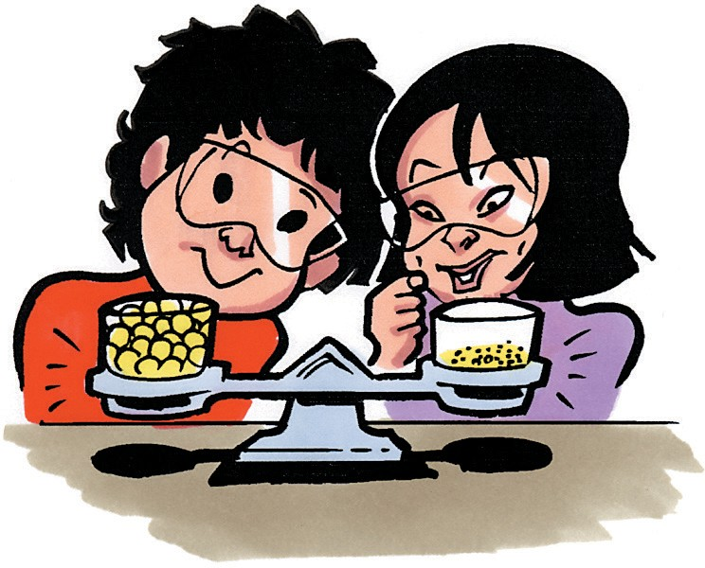
- Your teacher did a demonstration with cereal balls. Look at the cups of cereal on the balance in the picture. Which cup contains more cereal?
Explain your answer.

- In the solubility test you will do, you will need to measure equal amounts of the five crystals. How will you measure equal amounts?

GET READY FOR THE NEXT ACTIVITY

Materials for Each Group
  - Gram balance
  - 5 small plastic cups
  - 5 clear plastic cups
  - Masking tape and pen or permanent marker
  - Salt
  - Epsom salt
  - MSG
  - Sugar
  - Unknown
  - Water

Procedure
- Use masking tape and a pen to label the 5 small plastic cups Salt, Epsom Salt, MSG, Sugar, and Unknown.
- Label the 5 larger clear plastic cups the same way.
- Weigh 5 g of each crystal and place each in its small, labeled cup.

ACTIVITY

Question to Investigate
Can you identify an unknown using a solubility test?

Materials for Each Group
  - Graduated cylinder
  - 5 g each of salt, Epsom salt, MSG, sugar, and unknown
  - 5 clear plastic cups
  - Water

Procedure
- Use a graduated cylinder to add 5 mL of room temperature water to each empty clear plastic cup.
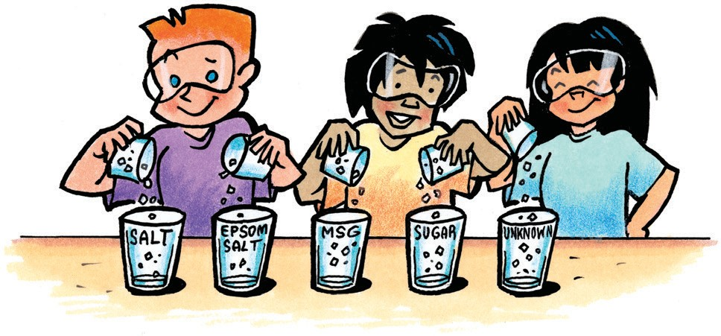
- Match up each pair of labeled cups so that each cup of crystal is near its corresponding cup of water.
- When your teacher tells you to, work with your lab partners to pour the weighed amount of each crystal into its cup of water at the same time.

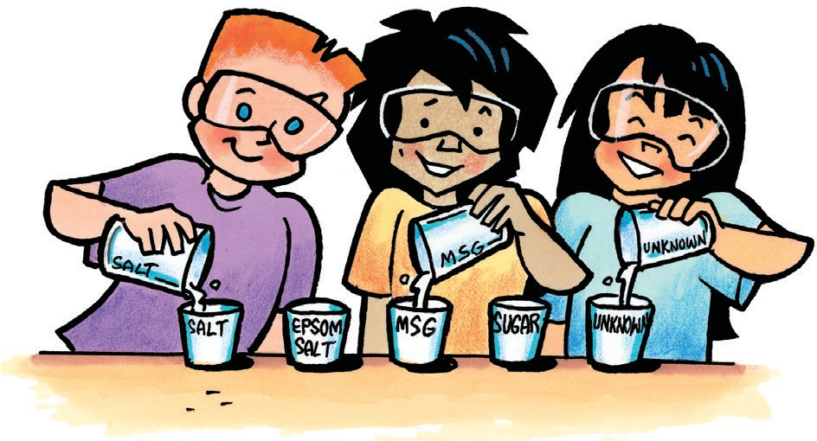
- With the help of your lab partners, swirl each cup at the same time and in the same way for about 20 seconds and observe. Swirl again for another 20 seconds and observe. Swirl again for the last 20 seconds and make your final observations.
- Slowly and carefully pour the solution from each cup back into its small empty cup. Try not to let any undissolved crystal go into the small cup. Compare the amount of crystal remaining in each clear plastic cup.

What did you learn about the unknown from the solubility test?
Unknown might be: | Unknown is probably not:
What evidence do you have to support your conclusion? | What evidence do you have to support your conclusion?

Question to Investigate
Will the crystals that form when the solutions evaporate help identify the unknown?

Materials for Each Group
  - Five solutions made in the activity, each in a small plastic cup
  - 5 clear plastic cups from the activity
  - Magnifier
  - Water
  - Paper towel

Procedure
- Rinse each large clear plastic cup with water to remove any remaining crystal. Dry each with a paper towel.
- Carefully pour the solution from each small cup into its corresponding large clear plastic cup.
- Allow the solutions to sit overnight.
- The next day, use a magnifier to carefully observe the crystals from both the top and bottom of the cup.
Describe each type of re-crystalized crystal.
Circle the one that you think is the unknown.
Salt | Epsom Salt
MSG | Sugar

EXPLAIN IT WITH ATOMS & MOLECULES
- On the molecular level, why do different substances have different solubilities?

- Why does the solubility test help you identify the unknown?

TAKE IT FURTHER
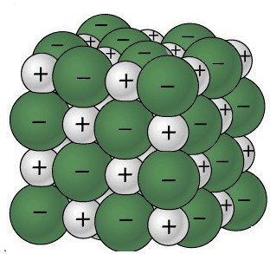
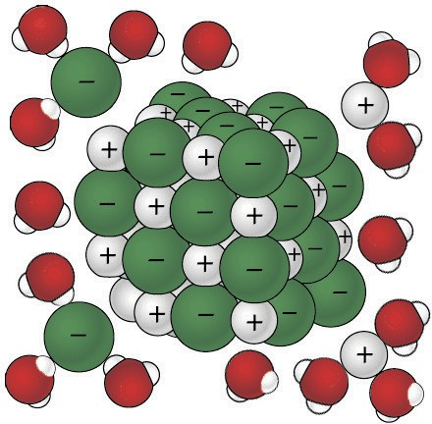
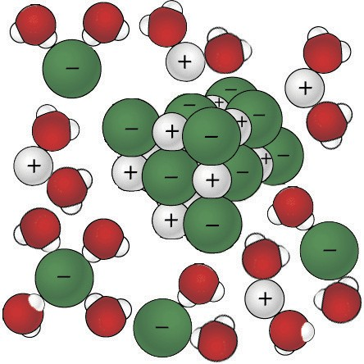
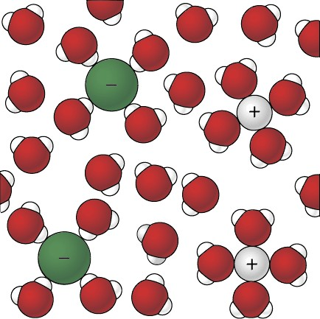
Sodium Chloride dissolving in water

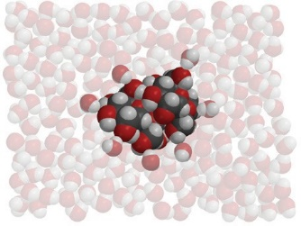
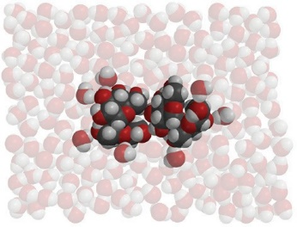
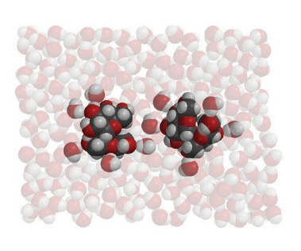
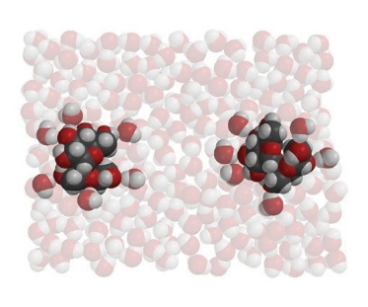
Sucrose dissolving in water

- What are the similarities and differences between salt dissolving in water and sugar dissolving in water?

